Chapter 1:
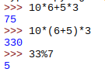
Question 1:

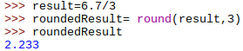
Question 2:

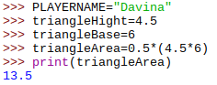
Question 3:

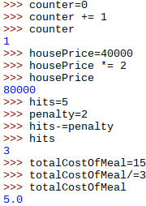
Question 4:

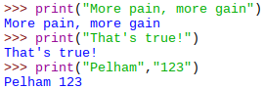
Question 5:
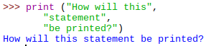

Exercises:

1.
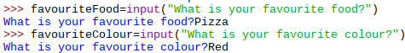
(a)

(b)

2.
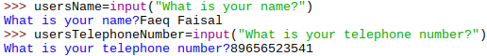
(a)

(b)

3.

(a)
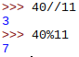

(b)

(c)
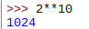

(d)
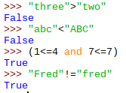

(e)

(f)

(g)

Chapter 2:
Question 1:
There needs to be another ‘)’ at the end of line 7
There needs to be ‘()’ after ‘.upper’ at the end of line 6
Exercises:
1.
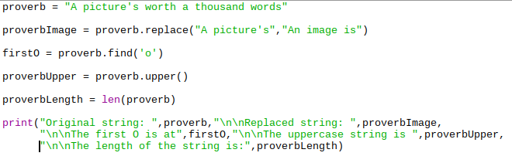
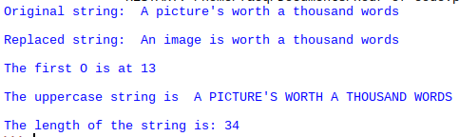

2.
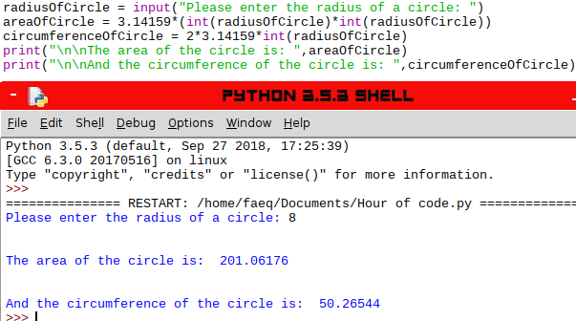

3.
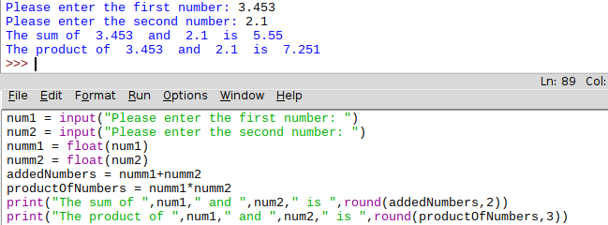

Chapter 3:
Question 1:
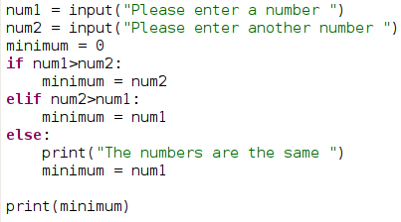

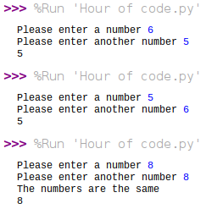

Question 2:
weekendRate = True

Exercises:
1.
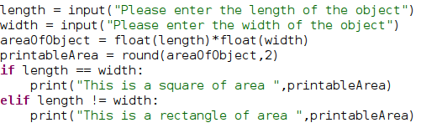

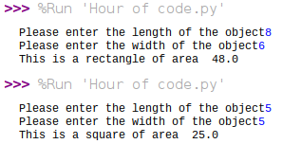

2.
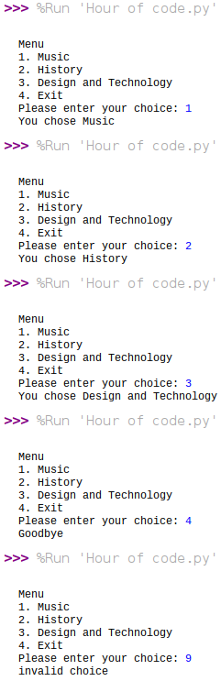
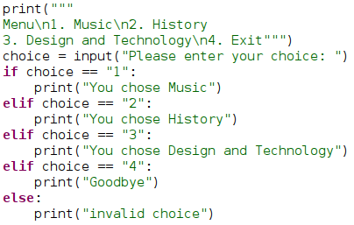

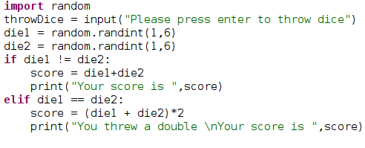
3.
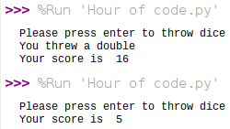

4.
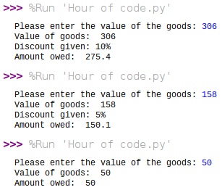
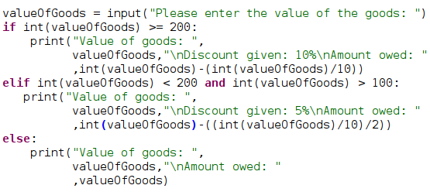

5.
